* Bit locker is user to encrypt VM
* Its key is stored In Key Vault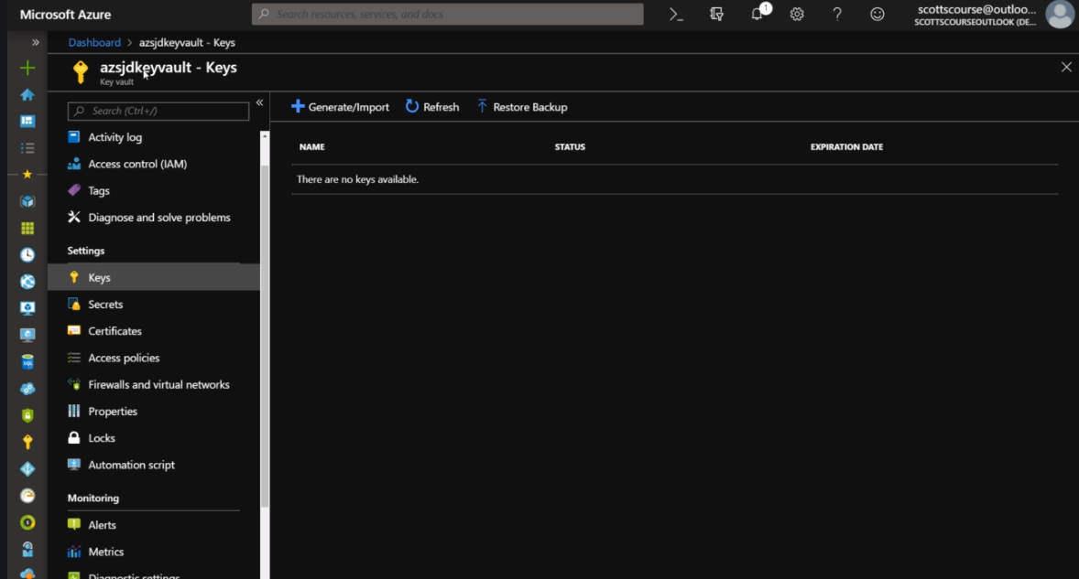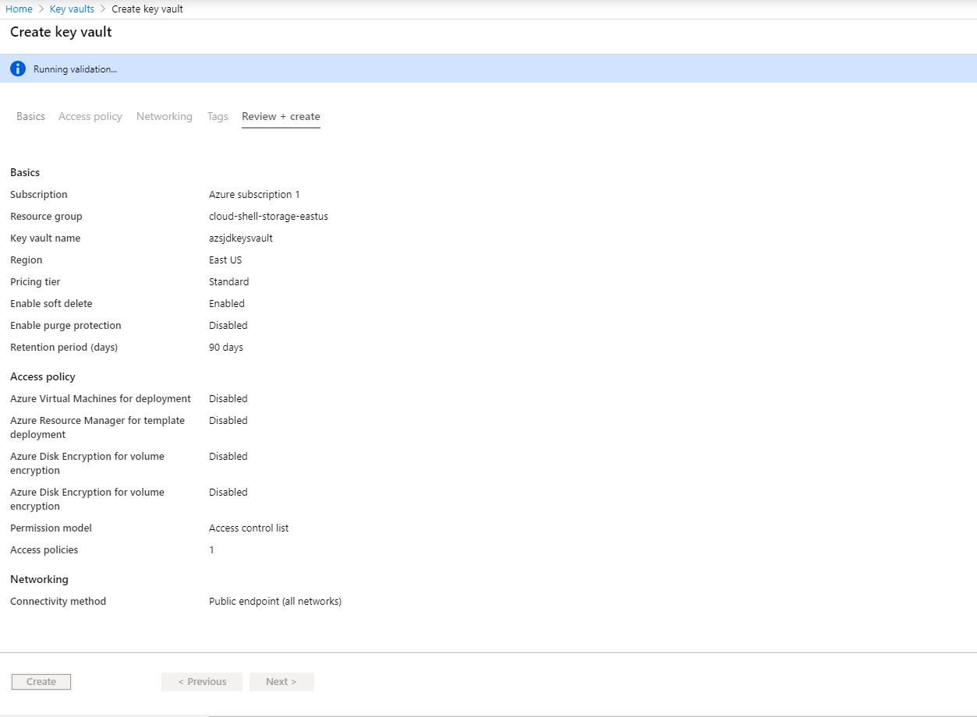
* Key Vault and VM should be in the same region
* Now generate a key. 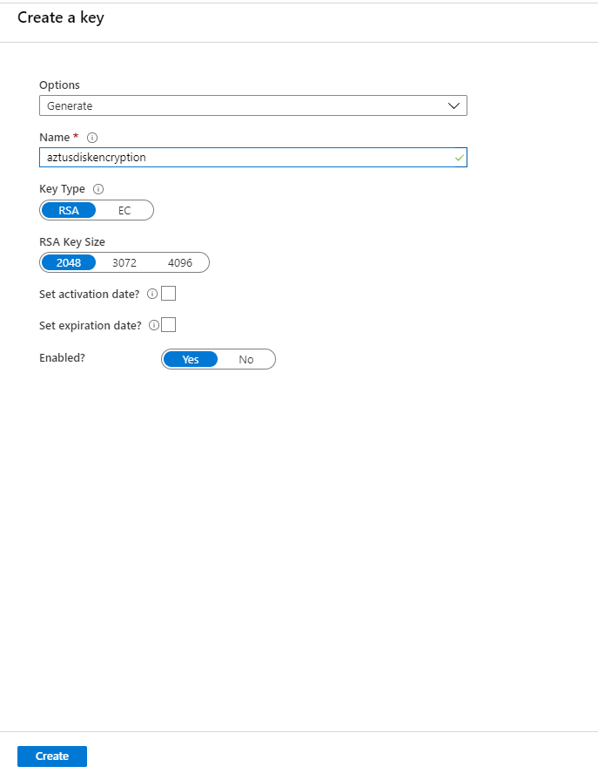
* You should have a virtual machine to encrypt it.
* Though the storage has its own encryption but the VM itself will be unencrypted while creation.
* Encryption of the disk will not be enabled dydefault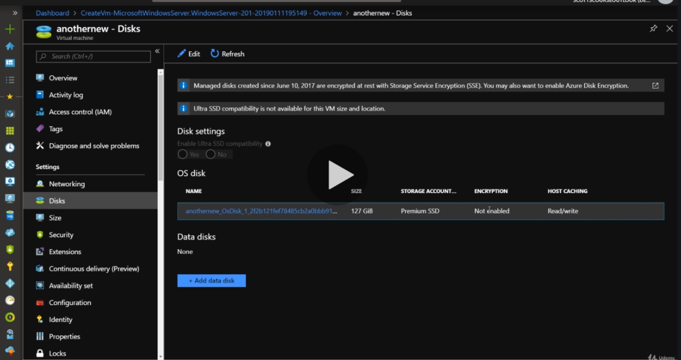
* User powershell to do that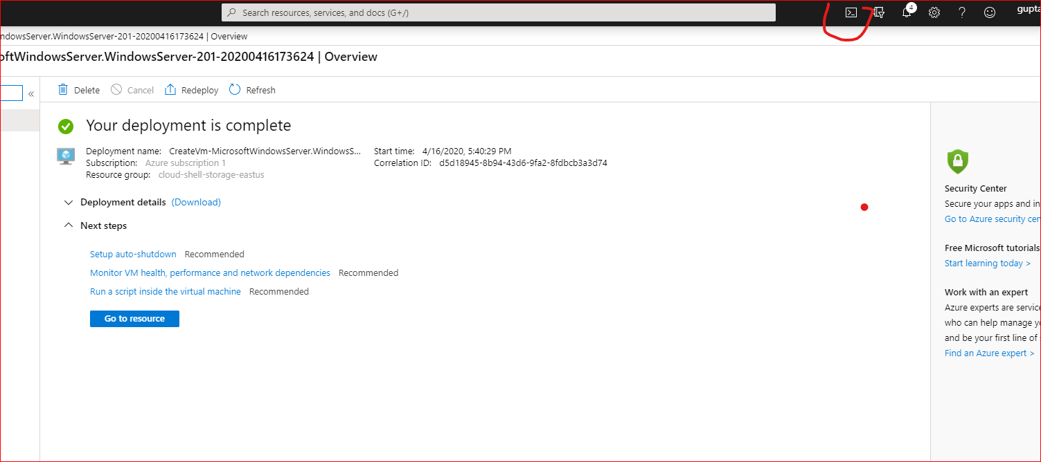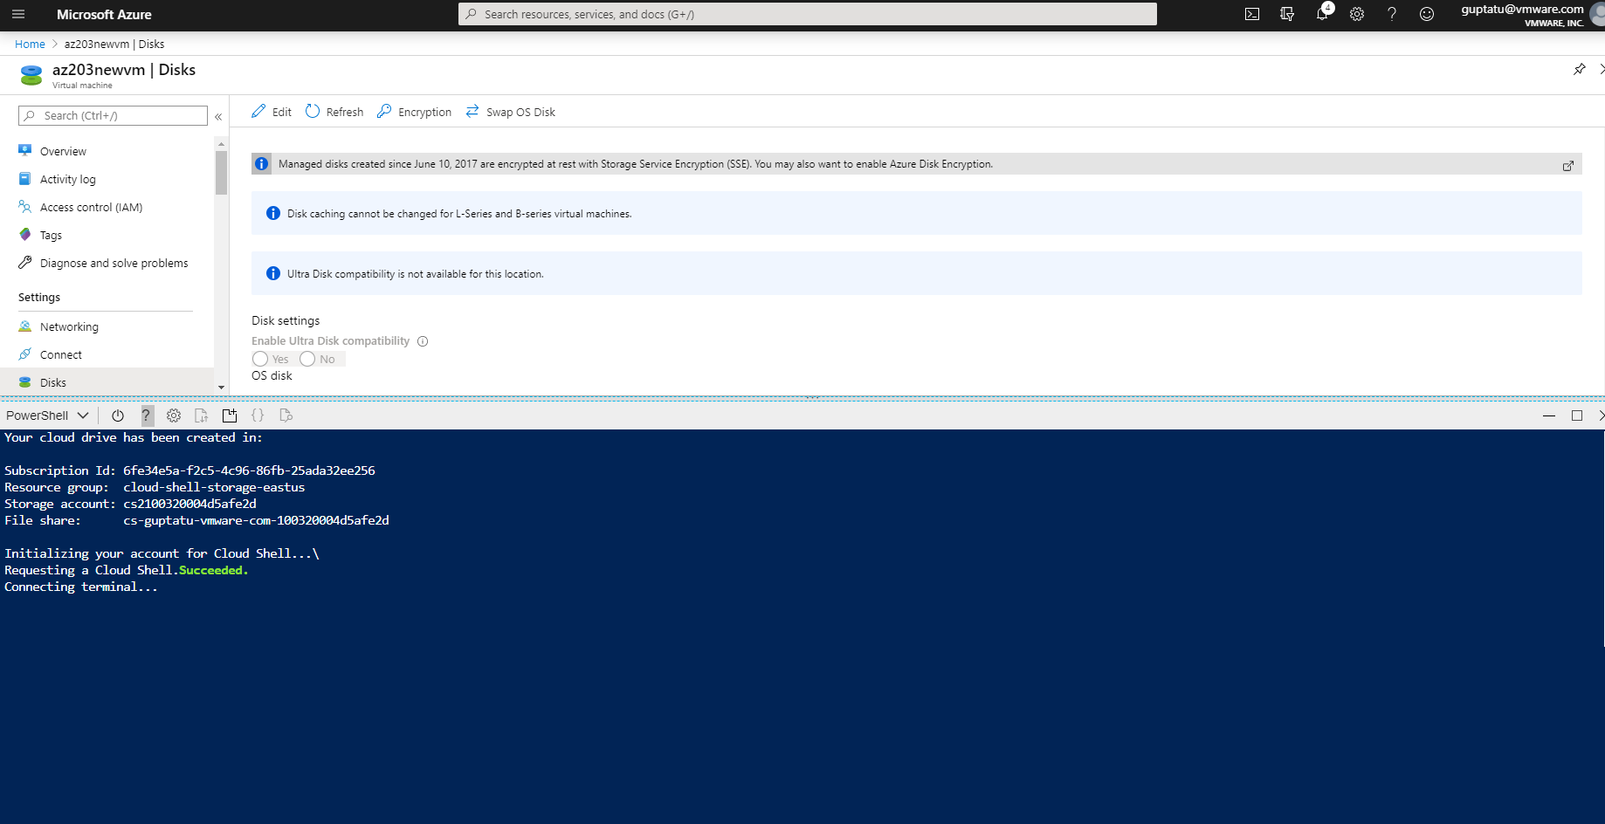
* Microsoft have a script to encrypt, goinf one line at a time to type it in powershell to use it.
* <https://docs.microsoft.com/en-in/azure/virtual-machines/scripts/virtual-machines-windows-powershell-sample-encrypt-vm?>
* Modify the resource name source the names according to you have.
* Save all the variables one by one and execute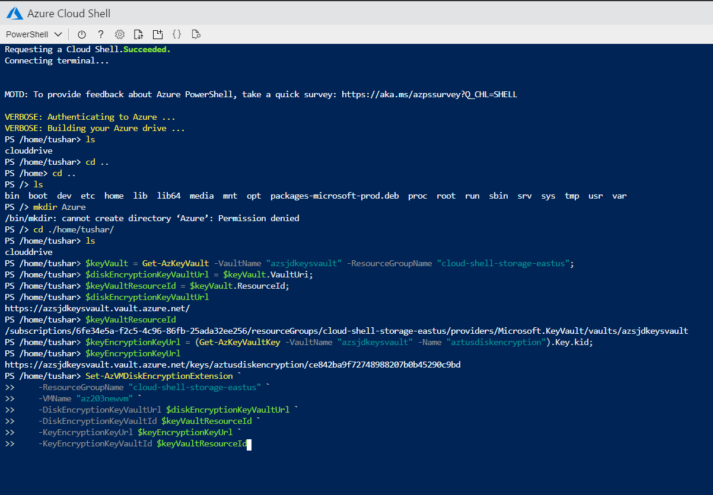
* Save your work and let it set for 15 minutes to execute the command.
* To Check if it is encrypted.
* 